**Final Project – Refactor Udagram App into Microservices and Deploy**

The source code for the project is at <https://github.com/rraerrabotu/udagram-refactor-project>

**Screenshot of Udagram deployed in EKS with External IP exposed**



**Containers and Microservices**

|  |  |  |
| --- | --- | --- |
| **Success Criteria** | **Specifications** | **Result** |
| Divide an application into microservices | /feed and /user backends are separated into independent projects. | ***Completed –*** *Please look at GitHub* |
| Build and run a container image using Docker | Project includes Dockerfiles to successfully create Docker images for /feed, /user backends, project frontend, and reverse proxy.  Screenshot of DockerHub shows the images. | ***Completed***   1. *Please look at GitHub* 2. *DockerHub screen shot attached below* |

**Screenshot of DockerHub**

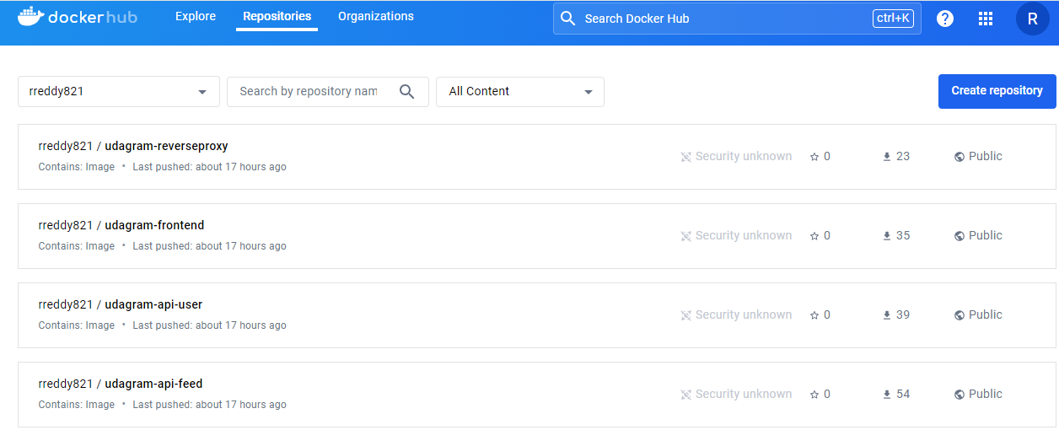

**Independent Releases and Deployments**

|  |  |  |
| --- | --- | --- |
| **Success Criteria** | **Specifications** | **Result** |
| Divide an application into microservices | Project includes a .travis.yml file.  Screenshot of the Travis CI interface shows a successful build and deploy job. | ***Completed –***   1. *Please look at GitHub for .travis.yaml* 2. *Screenshot of Travis CI* |

**Screenshot of the Travis CI interface**

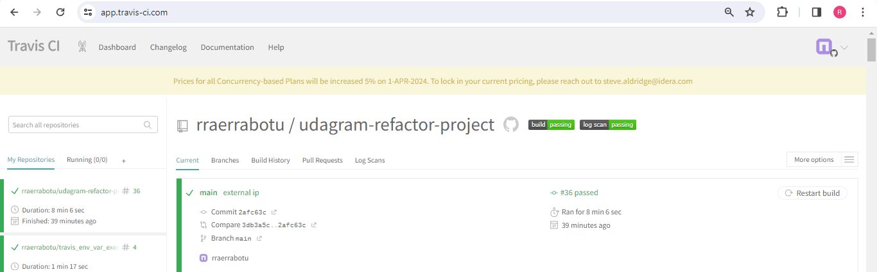

**Service Orchestration with Kubernetes**

|  |  |  |
| --- | --- | --- |
| **Success Criteria** | **Specifications** | **Result** |
| Deploy microservices using a Kubernetes cluster on AWS | A screenshots of kubectl commands show the Frontend and API projects deployed in Kubernetes.  The output of kubectl get pods indicates that the pods are running successfully with the STATUS value Running.  The output of kubectl describe services does not expose any sensitive strings such as database passwords. | ***Completed – Screenshots below*** |

**Screenshot of the “kubectl”commands**

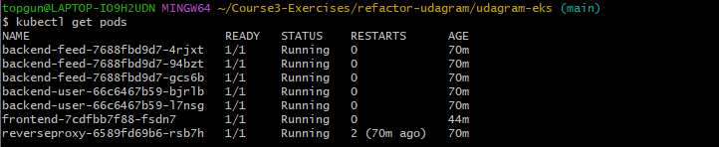

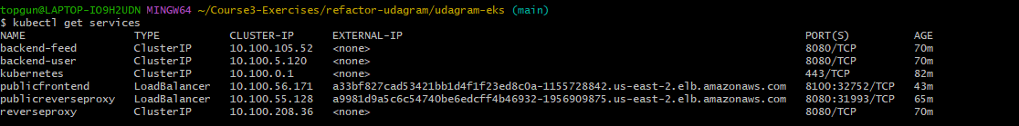

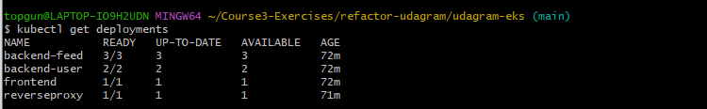

**kubectl_describe_services output -** [*https://github.com/rraerrabotu/udagram-refactor-project/blob/main/udagram-finalproject-submission/kubectl_describe-services-output.txt*](https://github.com/rraerrabotu/udagram-refactor-project/blob/main/udagram-finalproject-submission/kubectl_describe-services-output.txt)

|  |  |  |
| --- | --- | --- |
| **Success Criteria** | **Specifications** | **Result** |
| Use a reverse proxy to direct requests to the appropriate backend | Screenshot of Kubernetes services shows a reverse proxy | ***Completed – Screenshot below*** |

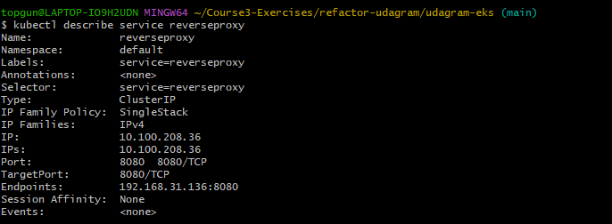

|  |  |  |
| --- | --- | --- |
| **Success Criteria** | **Specifications** | **Result** |
| Configure scaling and self-healing for each service | Kubernetes services are replicated. At least one of the Kubernetes services has replicas: defined with a value greater than 1 in its deployment.yml file.  Screenshot of Kubernetes cluster of command kubectl describe hpa has autoscaling configured with CPU metrics. | ***Completed – Screenshot below*** |

***Showing Replicas***

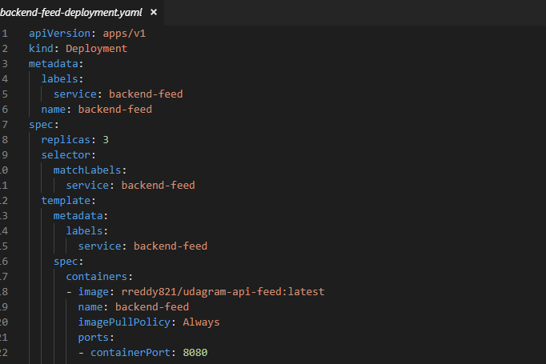

***HPA Setup for backend-feed – Updated based on review feedback***

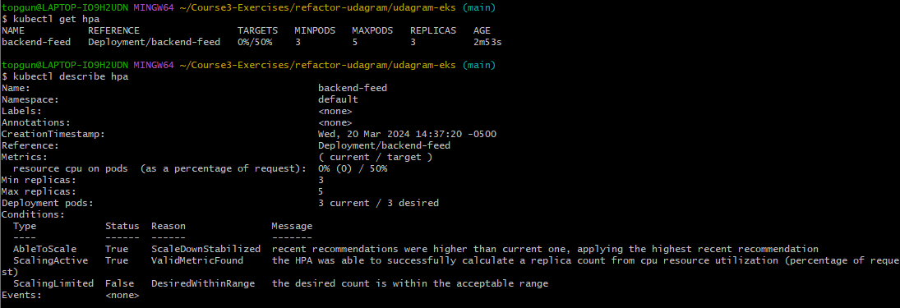

**Debugging, Monitoring, and Logging**

|  |  |  |
| --- | --- | --- |
| **Success Criteria** | **Specifications** | **Result** |
| Use logs to capture metrics for debugging a microservices deployment | Screenshot of one of the backend API pod logs indicates user activity that is logged when an API call is made. | ***Completed – Screenshot below*** |

